University Database

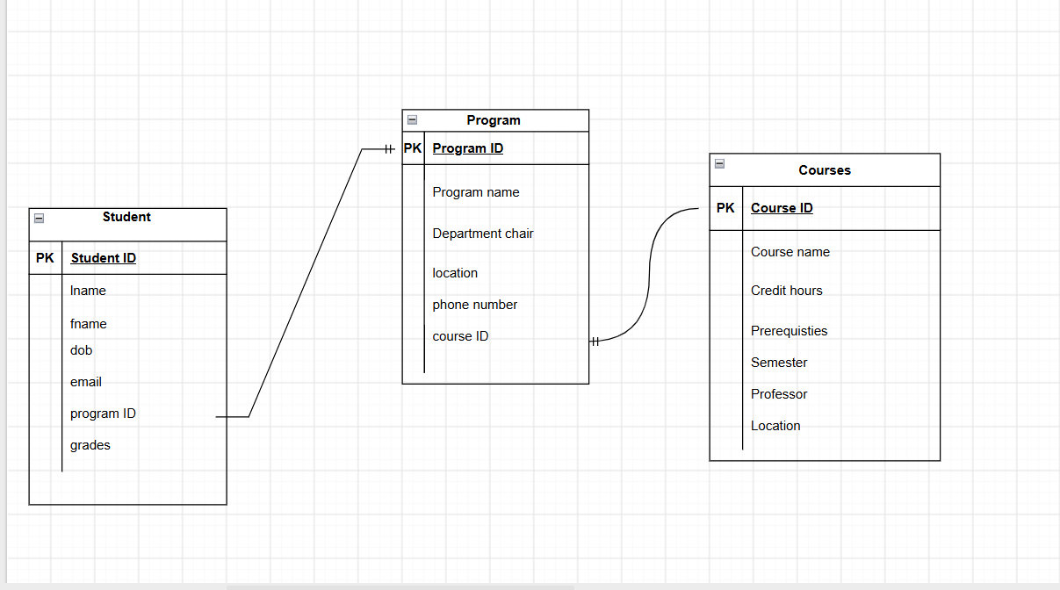

The entity, Student, has six attributes: last name, first name, DOB, email, program ID, and grades. Program ID connects the student to the program table. The student ID is the primary key of the student table.
The entity, Program, has five attributes: program name, department chair, location, phone number, and course ID. The course ID connects the program table to the courses table. The program ID is the primary key for the program table and the course ID is the primary key for the courses table.

